cmd1. Define a class to represent a bank account. Include the following members:

Data Members:

a.Name of the Depositor

b.Account Number

c.Type of Account

d.Balance amount in the account

Data Methods:

a.To assign initial values

b.To deposit an amount

c.To withdraw an amount

d.To display name and balance.

import java.io.*;

import java.util.*;

import java.util.Scanner;

import java.util.Random;

class Bank

{

public String nameOfDepositor;

public int accNumber;

public String accType;

public double balanceAmount;

public void assignValues(String nameOfDepositor, String accType, double balanceAmount)

{

this.nameOfDepositor=nameOfDepositor;

this.accType=accType;

this.balanceAmount=balanceAmount;

Random random = new Random();

this.accNumber=random.nextInt(1000000);

System.out.println("Your new account number is: "+accNumber);

}

public void depositAmount(double amount)

{

if(accNumber==0)

System.out.println("!You don't have bank account to deposit\nNote:please assign values to create an account");

else

{

balanceAmount+=amount;

System.out.println("Amount deposited successfully...");

}

}

public void withdrawAmount(double amount)

{

if(accNumber==0)

System.out.println("!You don't have bank account to credit\nNote:please assign values to create an account"); else if(balanceAmount>amount)

{

balanceAmount-=amount;

System.out.println("Amount credited successfully...");

} else

System.out.println("! Insufficient balance");

}

public void displayDetails()

{

if(accNumber==0)

System.out.println("!You don't have bank account\nNote:please assign values to create an account");

else

{

System.out.println("Name of the Depositor: "+nameOfDepositor);

System.out.println("Balance amount in the account: "+balanceAmount);

}

}

public void getInput()

{

System.out.println("How can i help you?");

System.out.println("1. Open account");

System.out.println("2. Deposit amount");

System.out.println("3. Withdraw amount");

System.out.println("4. Account details");

System.out.println("5. Exit");

System.out.print("Please Enter Your choose : ");

}

}

class member_109

{

public static void main(String[] s) throws IOException

{

System.out.println(":::::::::::: WELCOME TO BANK OF BARODA ::::::::::::");

Bank newAccount=new Bank(); Scanner scan=new Scanner(System.in);

boolean process=true;

int continueState=0;

while(continueState!=5)

{

newAccount.getInput();

int currentProcess=scan.nextInt();

if(currentProcess==1)

{

System.out.println("********************************************** *********");

System.out.print("Enter your name: ");

String nameOfDepositor=scan.next();

System.out.print("Enter your account type: ");

String accType=scan.next();

System.out.print("Enter your opening balance: ");

double balanceAmount=scan.nextDouble();

newAccount.assignValues(nameOfDepositor, accType, balanceAmount);

}

else if(currentProcess==2)

{

System.out.println("********************************************** *********");

System.out.print("Enter amount to deposit: ");

newAccount.depositAmount(scan.nextDouble());

}

else if(currentProcess==3)

{

System.out.println("********************************************** *********");

System.out.println("Your current Balance in the account: "+newAccount.balanceAmount);

System.out.print("Enter amount to withdraw: ");

newAccount.withdrawAmount(scan.nextDouble());

}

else if(currentProcess==4)

{ System.out.println("*******************************************************");

newAccount.displayDetails();

}

else if(currentProcess==5)

{

System.out.println("*******************************************************");

continueState=5;

System.out.println("THANK YOU FOR VISITING OUR BANK.");

}

System.out.println();

System.out.println("X X X X X X X X X X X X X X X X X X X X X X X X X X X X");

System.out.println();

}

System.out.println("--------------------------------------------------------------------------------------------");

}

}

Output :

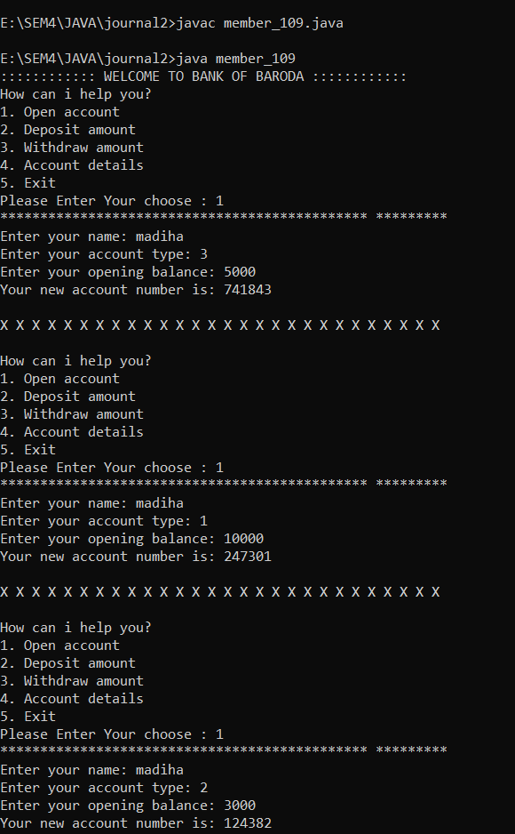

2. Write a program to print Floyd’s triangle where n is command line input.

1

2 3

4 5 6

7 8 9 10

class triangle_109

{

static void printFloydTriangle(int n)

{

int i, j, val = 1;

for (i = 1; i <= n; i++) {

for (j = 1; j <= i; j++) {

System.out.print(val + " ");

val++; }

System.out.println();

} }

public static void main(String[] args)

{

int i= Integer.parseInt(args[0]);

printFloydTriangle(i);

}

}

Output :

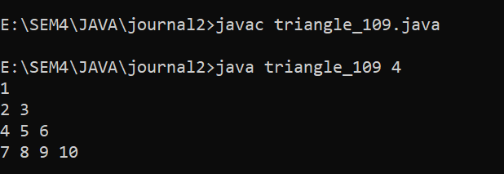

3. Design a class Cricketer having data member name and a number of matches and appropriate member function to set the values. Derived two classes Batsman and Bowler from cricketer class with data member total number of runs and wickets respectively. Batsman class is having method to calculate average wicket. Write a program to create two objects and display information of one batsman and bowler along with average run and wicket.

import java.util.Scanner;

class Cricketer

{

public String cname;

public int nom;

public void setDataMain()

{

Scanner sc = new Scanner(System.in);

System.out.print("Enter the name of Cricketer: ");

cname = sc.nextLine();

Scanner sc2 = new Scanner(System.in);

System.out.print("Enter the Number of matches of Cricketer: ");

nom = sc2.nextInt();

}

public void displayDataMain()

{

System.out.println("Name " +cname);

System.out.println("Matches " +nom);

}

}

class Batsman extends Cricketer

{

public int total_run; public float average;

public void setData()

{

Scanner sc4 = new Scanner(System.in);

System.out.print("\nEnter the Total Number of Runs: ");

total_run = sc4.nextInt();

}

public void displayData()

{

System.out.println("Total Runs "+total_run);

}

}

class Bowler extends Cricketer

{

public int wickets;

public float average;

public void setData()

{

Scanner sc3 = new Scanner(System.in);

System.out.print("Enter the number of wickets: ");

wickets = sc3.nextInt();

}

public void displayData()

{

System.out.println("Wickets "+wickets);

}

}

public class batsman_109

{

public static void main(String[] args)

{

Bowler bowl = new Bowler();

Batsman bat = new Batsman();

Cricketer cal = new Cricketer();

cal.setDataMain();

bat.setData();

bowl.setData();

cal.displayDataMain();

bat.displayData();

bowl.displayData();

bowl.average = (float) bowl.wickets/cal.nom;

bat.average = (float) bat.total_run/cal.nom;

System.out.println("Average_Run's: "+bat.average);

System.out.println("Average_Wicket's: "+bowl.average);

}

}

Output :

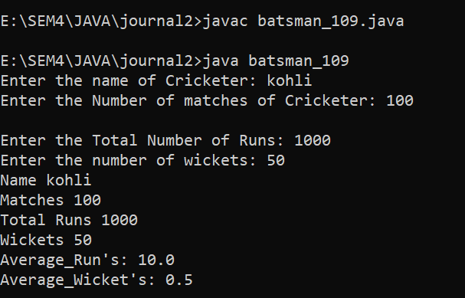

4. Write a program that will accept two strings or two numbers from command line and create overloaded method that add these

two numbers or concate two strings.

import java.io.*;

class overloaded_109

{

static boolean isNumber(String s)

{

for(int i=0;i<s.length();i++)

if(Character.isDigit(s.charAt(i))==false)

return false;

return true;

}

void add(int a, int b)

{

System.out.println("Result is : "+(a+b)) ;

}

void add(String a, String b)

{

System.out.println("Result is : "+(a+b));

}

public static void main(String[] args)

{

overloaded_109 obj = new overloaded_109 ();

if(isNumber(args[0])&&isNumber(args[1]))

{

int a=Integer.parseInt(args[0]);

int b=Integer.parseInt(args[1]);

obj.add(a,b);

}

else

obj.add(args[0],args[1]);

}

}

Output:

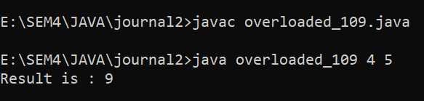

5. Write a program that accept a number from command line and check whether it is palindrome or not.

public class commandline_109

{

public static void main(String args[])

{

int n = Integer.parseInt(args[0]);

int sum = 0, r;

int temp = n;

while(n>0)

{

r = n % 10;

sum = (sum*10)+r;

n = n/10;

}

if(temp==sum)

System.out.println("It is a Palindrome No.");

else

System.out.println("It's Not a palindrome No.");

}

}

Output :

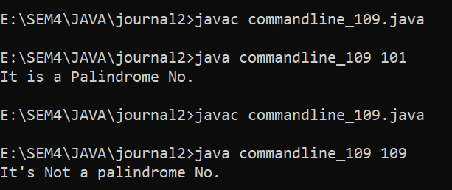

6. Write a program that will accept a string from command line and arrange all the characters in alphabetical order. E.g. input- computer output-cemoprtu

public class alphabetical_109

{

public static void main(String args[])

{

String str = args[0];

str = str.toLowerCase();

int len = str.length();

String sortedStr = "";

//Empty String

for (char ch = 'a'; ch <= 'z'; ch++)

{

for (int i = 0; i < len; i++)

{

char strCh = str.charAt(i);

if (ch == strCh)

{

sortedStr += strCh;

}

}

}

System.out.println("Alphabetical order : "+sortedStr);

}

}

Output :

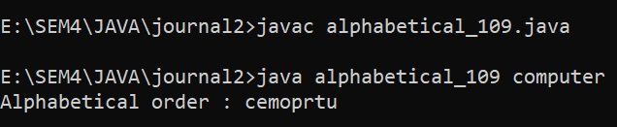

7. Write a program to create interface Area. Create three classes called rectangle, triangle and square calculate areas respectively.

import java.util.Scanner;

interface area

{

double calc(double x,double y);

}

class rectangle implements area

{

public double calc(double x,double y)

{

return(x*y);

}

}

class triangle implements area

{

public double calc(double x,double y)

{

return((x*y)/2);

}

}

class square implements area

{

public double calc(double x,double y)

{

return(x*x);

}

}

class interface_area109

{

public static void main(String arg[])

{

int p,q;

Scanner in = new Scanner(System.in);

rectangle r = new rectangle();

triangle c = new triangle();

square s = new square();

area a;

a = r;

System.out.print("\nEnter hight of Rectangle : ");

p=in.nextInt();

System.out.print("Enter width of Rectangle : ");

q=in.nextInt();

System.out.println("\nArea of Rectangle is : " +a.calc(p,q));

a = c;

System.out.print("\nEnter hight of Triangle : ");

p=in.nextInt();

System.out.print("Enter Breath of Triangle : ");

q=in.nextInt();

System.out.println("\nArea of Triangle is : " +a.calc(p,q));

a = s;

System.out.print("\nEnter Side of Square : ");

p=in.nextInt();

System.out.println("\nArea of Square is : " +a.calc(p,p));

}

}

Output:

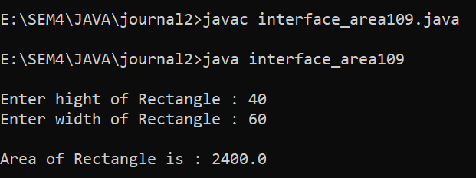

8. Write a program that will accept a number from command line and raise a user defined exception if the number consists of odd number of digits.

class OddNumberOfDigitsException extends Exception

{

public OddNumberOfDigitsException(String message)

{

super(message);

}

}

public class Uexception_109

{

public static void main(String[] args)

{

int numberString = Integer.parseInt(args[0]);

int temp=numberString;

int x;

try

{

while(numberString>0)

{

x=numberString%10;

numberString=numberString/10;

if (x % 2 != 0)

{

throw new OddNumberOfDigitsException("The number has an odd number of digits");

}

}

}

catch (ArrayIndexOutOfBoundsException e)

{

System.out.println("Please provide a number as a command-line argument.");

}

catch (OddNumberOfDigitsException e)

{

System.out.println(e.getMessage());

}

}

}

Output :

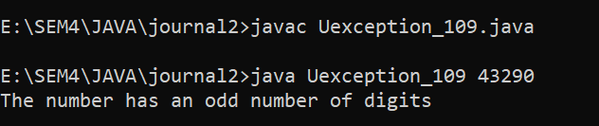

9. Write a java application which accepts 10 names of student and their age. Sort names and age in descending order. (Using Array)

import java.util.Arrays;

import java.util.Scanner;

public class age_109

{

public static void main(String[] args)

{

Scanner scanner = new Scanner(System.in);

String[] names = new String[10];

int[] ages = new int[10];

for (int i = 0; i < 10; i++)

{

System.out.print("Enter name of student " + (i + 1) + ": ");

names[i] = scanner.nextLine();

System.out.print("Enter age of student " + (i + 1) + ": ");

ages[i] = scanner.nextInt();

scanner.nextLine();

}

while (true) {

System.out.println("\nSelect an option:");

System.out.println("1. Sort via Name.");

System.out.println("2. Sort via Age.");

System.out.println("3. Exit");

System.out.print("\nSelect Your Choice : ");

int choice = scanner.nextInt();

scanner.nextLine();

switch (choice) {

case 1:

for (int i = 0; i < 10; i++) {

for (int j = i + 1; j < 10; j++) {

if (names[i].compareToIgnoreCase(names[j]) < 0)

{

String tempName = names[i];

names[i] = names[j];

names[j] = tempName;

int tempAge = ages[i];

ages[i] = ages[j];

ages[j] = tempAge;

}

}

}

System.out.println("\nSorted Names in Descending Order:");

for (int i = 0; i < 10; i++) {

System.out.println(names[i] + " - " + ages[i]);

}

break;

case 2:

for (int i = 0; i < 10; i++)

{

for (int j = i + 1; j < 10; j++)

{ if (ages[i] < (ages[j]))

{ int tempage = ages[i];

ages[i] = ages[j];

ages[j] = tempage;

String tempname = names[i];

names[i] = names[j];

names[j] = tempname;

}

}

}

System.out.println("\nSorted Ages in Descending Order:");

for (int i = 0; i < 10; i++)

{

System.out.println(ages[i] + " - " + names[i]);

}

break; case 3:

System.out.println("Exiting program...");

System.exit(0);

break;

default:

System.out.println("Invalid choice. Try again.");

}

}

}

}

Output :

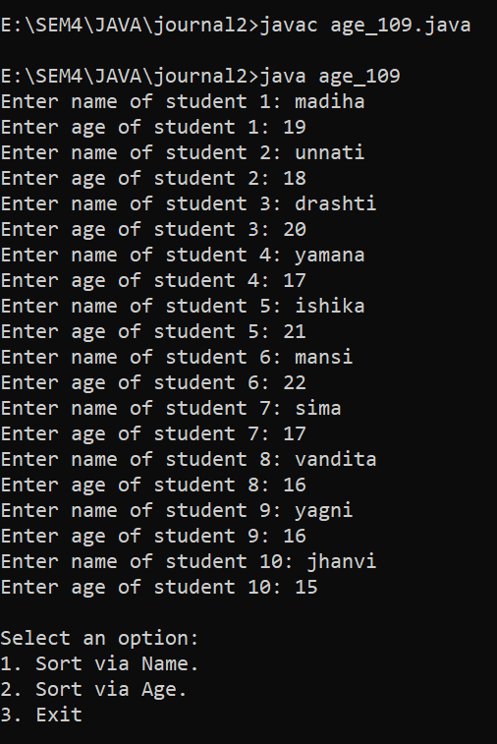

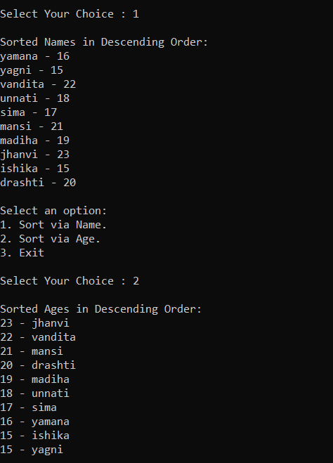

10. Design a class MyString having a data member of type String and add member functions to achieve following task. (i) Reverse string (ii) String in Titlecase. (iii) Extract N-characters from rightend of the string Write a menu driven program to call these methods of MyString class. The program should not terminate abruptly.

import java.util.Scanner;

public class MyString_109

{

private String str;

public MyString_109(String str)

{

this.str = str;

}

public String reverse()

{

StringBuilder sb = new StringBuilder(str);

return sb.reverse().toString();

}

public String titleCase()

{

String[] words = str.split("\\s+");

StringBuilder sb = new StringBuilder();

for (String word : words)

{

if (word.length() > 0)

{

sb.append(Character.toUpperCase(word.charAt(0)));

sb.append(word.substring(1).toLowerCase());

sb.append(" ");

}

}

return sb.toString().trim();

}

public String extractFromRight(int n)

{

if (n >= str.length())

{

return str;

}

return str.substring(str.length() - n);

}

public static void main(String[] args)

{

Scanner scanner = new Scanner(System.in);

System.out.print("Enter a string: ");

String inputString = scanner.nextLine();

MyString_109 myString = new MyString_109(inputString);

while (true)

{

System.out.println("\nSelect an option:");

System.out.println("1. Reverse the string");

System.out.println("2. Convert the string to title case");

System.out.println("3. Extract N characters from the right-end of the string");

System.out.println("4. Exit");

System.out.print("\nSelect Your Choice : ");

int choice = scanner.nextInt();

scanner.nextLine();

switch (choice)

{

case 1:

System.out.println("Reversed string: " + myString.reverse());

break;

case 2:

System.out.println("Title case string: " + myString.titleCase());

break;

case 3:

System.out.print("Enter the number of characters to extract: ");

int n = scanner.nextInt();

scanner.nextLine();

System.out.println("Extracted string: " + myString.extractFromRight(n));

break;

case 4:

System.out.println("Exiting program...");

System.exit(0);

break;

default:

System.out.println("Invalid choice.");

}

}

}

}

Output :

